The Taming of the Shrew by William Shakespeare

Summer Reading Assignment Enhanced English 10

This quarter, your task is to read *The Taming of the Shrew* by William Shakespeare and complete the attached assignments. The No Fear Shakespeare version of the play is online at Sparks Notes (the column on the left is the original version; the column on the right is the modern version). There is also one book of this version in the library for anyone who may need it. The expectation for honors English 9 is that you will read the Shakespearian text and use the modern translation only to check for comprehension or to help guide your interpretation in the event you miss class.

**Be prepared to discuss:**

* The elements of comedy seen within the play
* The role social class plays within the text
* The social expectations of women during the Tudor time period

**Terms to know:**

**Double Entendre:** A word or phrase with a double meaning. The second meaning is usually sexual in nature. (Think “that’s what she said” jokes)

**Foil:** Two characters that are polar opposites of each other. One character usually makes the other look better in comparison. (You will be asked to identify three foils within this story)

**Shrew**: A woman who speaks harshly, acts out violently, and does not obey social norms.

**Monologue**: A form of dramatic entertainment, comedic solo, or a prolonged speech by a single speaker; especially one dominating or monopolizing a conversation.

**Soliloquy**: A speech in which a character is talking to himself or herself; a device used in drama to disclose a characters inner most thoughts.

**Things to Expect:**

Some of the characters switch identities and wear disguises. Although this is meant to add dramatic irony to the play, it can make for tedious reading at times, so be prepared to pay attention.

*The Taming of the Shrew* is a “play within a play.” This means that some of the characters at the start of the play are actually performing *The Taming of the Shrew* for other characters.

This story is all about one man’s attempt to tame and transform a shrew into a proper woman of the Tudor Era. However, although this play is meant to be a comedy, many critics have argued that it is a sexist play. Some believe it is about the “tyranny of man over woman,” and that in the end, Kate is “demeaned and forced to submit to her husband.” Other critics argue however, that in the end, Kate submits to her husband by choice – not force.

I’ll let you be the judge once we are finished….

**Who’s Who in Padua**

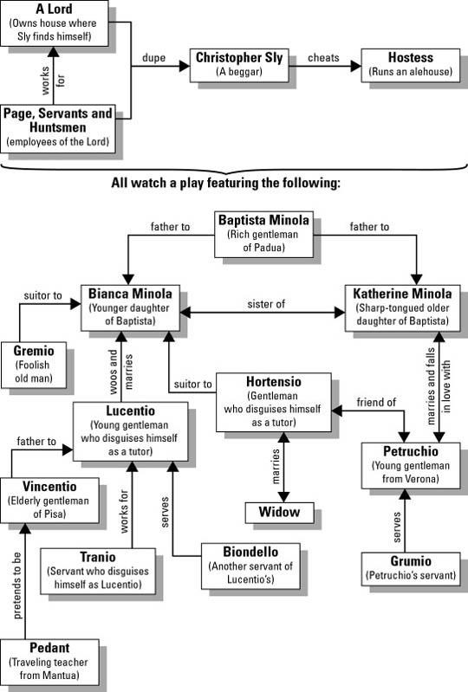

|  |  |  |  |
| --- | --- | --- | --- |
| Character’s Name | Their relation to other characters in the play (i.e.  sister to…, suitor to…, servant to…, etc.) | Character Description (what does the character look like, what is the characters  personality like, how do others perceive the character) | What should we remember about this character? (Think  of quotes, important scenes, important things the character does) |
| Christopher Sly |  |  |  |
| The Lord |  |  |  |
| Baptista Minola |  |  |  |
| Katherine |  |  |  |

|  |  |  |  |
| --- | --- | --- | --- |
| Character’s Name | Their relation to other characters in the play (i.e.  sister to…, suitor to…, servant to…, etc.) | Character Description (what does the character look like, what is the characters  personality like, how do others perceive the character) | What should we remember about this character? (Think  of quotes, important scenes, important things the character does) |
| Bianca |  |  |  |
| Gremio        Hortensio |  |  |  |
| Petruchio |  |  |  |
| Grumio |  |  |  |
| Lucentio |  |  |  |
| Character’s Name | Their relation to other characters in the play (i.e.  sister to…, suitor to…, servant to…, etc.) | Character Description (what does the character look like, what is the characters  personality like, how do others perceive the character) | What should we remember about this character? (Think  of quotes, important scenes, important things the character does) |
| Tranio |  |  |  |
| Biondello |  |  |  |
| Merchant |  |  |  |

***The Taming of the Shrew* - Study Questions**

Answer the following questions in complete sentences; be specific and use quotes from the play to support your work where possible.

# INDUCTION

1. What trick is played upon Christopher Sly? Why?

1. Why is "The Taming of the Shrew" considered a play within a play?

# ACT I, scene 1

1. Why has Lucentio come to Padua?

1. What has Baptista decided concerning the marriage of his two daughters?

1. What is Katherine's reputation? What is Bianca's reputation?

1. What is Hortensio and Gremio’s plan to more quickly be able to win and marry Bianca?

1. What is Tranio's plan for Lucentio? What transformation does this involve?

# ACT I, scene 2

1. Why has Petruchio come to Padua?

1. What does Petruchio's monologue (l.194-206) reveal about him?

1. What plan does Hortensio develop in the hopes that he will better his chances to win Bianca’s love?

# Act II, Scene 1

1. What information does Katherine hope to gain by tying Bianca's hands and questioning her?

1. What type of language does Petruchio use to describe Katherine during his discussion with Baptista? (l. 42-53) Why do you think he does this?

1. What names do Hortensio and Lucentio assume? What roles will they play?

1. What character does Tranio assume?

1. What does Baptista say Petruchio must do before he will allow him to marry Katherine? What

does this reveal about Baptista’s character?

1. How is Hortensio injured?

1. When Katherine and Petruchio meet how do they get along? Be specific.

1. What agreement does Petruchio claim he and Katherine have come to near the end of this scene? How does Baptista react?

1. At the end of Act II what are Tranio, Gremio, and Baptista discussing? What decision is made?

1. What must Tranio do in light of this decision?

# Act III, Scene 1

1. What is Bianca's response to Lucentio's (Cambio's) and Hortensio's (Litio's) argument over who will tutor Bianca first? What does this reveal about her character?

1. What is Lucentio's translation of his lesson? (lines 32-36) What is Bianca's translation of the same passage? (lines 40-43)

1. What message to Bianca does Hortensio (Litio) encode in the gamut (scales)? What is her response? (lines 71-78)

1. By the end of this scene, what does Hortensio decide?

# Act III, Scene 2

1. Why does Kate weep before the wedding? What aspect of her character does this reveal?

1. How is Petruchio dressed for his wedding? Give at least 4 specific details. What is the reaction of Baptista?

1. How does Petruchio respond when asked to change his clothes? How might this be a stab at common social views of the time?

1. What do you learn of Lucentio's plan to marry Bianca?

1. What does Gremio call Petruchio and Katherine when he tells Lucentio and Tranio about what took place at the wedding? Why is this ironic?

1. What does Petruchio do during the wedding ceremony to embarrass Katherine?

# ACT IV, Scene 1

1. What has happened to Kate on her way to Petruchio's house? How did Petruchio respond?

1. How does Petruchio treat the servants? What is Kate's reaction?

1. According to his soliloquy, how does Petruchio plan to tame Katherine?

# Act IV, Scene 2

1. Summarize Tranio and Hortensio's conversation concerning Bianca. What do they both decide? What is ironic about this?

1. What are Hortensio's plans for marriage?

1. What role does the merchant play in Tranio's plot? How does Tranio get him to play along?

# Act IV, Scene 3

1. What does Kate's opening monologue reveal about her condition?

1. Petruchio teaches Katherine four lessons in this scene. What are they?

# Act IV, Scene 4

1. After the negotiation between Baptista and Lucentio’s fake father, why doesn’t Baptista want to sign the wedding papers at his house?

1. What does Biondello tell Lucentio (Cambio) to do while Baptista feasts with Tranio?

# Scene 5

1. How does Petruchio test Katherine on the journey back to Baptista’s home? List both tests.

1. Who is Vincentio and what information does Petruchio let spill to him?

**ACT V, Scene 1**

1. What does Vincentio think has happened to his son?

1. How do the fathers react to the news of Bianca and Lucentio's wedding?

# Act V, Scene 2

1. What offensive comment does the widow make to Kate? What does Petruchio tell Kate to do?

1. Describe the bet made between the men. What do the majority of the men expect will be the outcome? What is the outcome?

1. What is the message of Kate's final monologue? Do you think she is sincere? Has she been tamed or is she only acting?

**Reflect back after Reading:**

1. What role do the servants play in this comedic story?

1. Why do you think Katherine was so angry for the majority of the play?

1. What is a double entendre? Provide an example from the play. (*hint: Act 2, Scene 1 has several)

1. Provide the three strongest examples of foils found in *Taming of the Shrew.*